**FBE 551 Quantitative Investing**

Team: Fat Finger

Trading Strategies in the Energy Futures Markets



|  |  |
| --- | --- |
| **Team Members:** |  |
|  | Imani Mufti  Jacbo Lee  Leon Man  Roman Sielewicz  Selene Xiang |

Table of Contents

1.0 Design 3

1.1 Introduction 3

1.2 Data Description 3

2.0 Research 4

3.0 Implementation 7

3.1 Mean-reverting trading strategies 7

3.1.1 Cointegration 8

3.1.2 Hedge ratio 8

3.1.3 Mean-reverting strategy on hedge portfolios 9

3.2 Momentum 10

3.3 Volatility 11

4.0 Testing 11

4.1 Mean-reverting Strategies 11

4.1.1 Variation 1: No hedge ratio (Inter-commodity spread) 11

4.1.2 Variation 2: Dynamic Hedge for Inter-commodity Spread 12

4.1.2 Variation 2: Dynamic Hedge for Calendar Spread 13

4.1.3 Portfolio Performance 14

4.2 Momentum 15

4.3 Volatility 18

5.0 Conclusion and Future Works 20

References 21

# 1.0 Design

## 1.1 Introduction

During the pandemic, energy markets have become extremely volatile due to the government-issued stay-at-home orders as well as depressed demand for many petroleum-based goods. In our final project, our team drew inspiration from a paper by Lubnau and Todorova (2015) and will focus on energy futures markets. As Ramirez and Rodriguez (2008) stated, commodity price patterns, especially in oil markets, are considered relatively efficient in the long term but subject to political and economic shocks in the short term. Also, based on the findings of Tabak and Cajueiro (2007), the energy markets might not be as efficient in the short term as they seem to be. Therefore our team will try to explore trading opportunities in energy markets by applying momentum, volatility and mean-reverting strategies.

## 1.2 Data Description

Datasets used in this article are obtained from the paper by Lubnau and Todorova (2015), and these datasets include the settlement price for the futures contracts with different maturity for WTI Crude Oil, Brent Crude Oil, Natural Gas, Heating Oil, and Gasoline. All futures in our samples are tradable at the CME (at both Globex and ClearPort Electronic platforms). Therefore our trading strategies are viable in reality. Table 1 summarizes the details of all four employed contracts in our samples.

Table 1. The Summary of All Four Employed Futures Contracts

|  |  |
| --- | --- |
| **Futures Contract (frequency)** | **Dataset Time Horizon** |
| Crude Oil (daily) | 08/10/1989 – 02/18/2014 |
| Gasoline (daily) | 10/03/2005 - 02/18/2014 |
| Heating oil (daily) | 01/01/1986 **-** 02/18/2014 |
| Natural gas (daily) | 08/13/1990 – 02/18/2014 |

As you can see, gasoline futures contract prices are only available starting from October 2005. Also, regarding the Brent Crude Oil futures contracts delivered at the 12 months, the first five years of price data was missing in the dataset.

Regarding the contract specifications, all these futures contracts are denominated in dollars per barrel. Each energy futures contract has its own corresponding number of underlying. For example, each WTI contract contains 1000 barrels. The aforementioned futures contracts are tradable almost around the clock except for a 1 hour break starting at 4 p.m. *EST.* Also, energy futures contracts are settled through physical delivery and their daily settlement price is calculated through the mechanism called *Trade at Settlement (TAS),* which refers to the process of determining the daily settlement price. This is achieved by computing volume weighted average price during the last 2 minutes of trading hours of each day.

# 2.0 Research

According to Grima and Paulson (1999), spreads between petroleum futures are highly cointegrated and stationary. Historical price data shows that profitable opportunities exist, evidenced by statistically significant returns that were achieved using various moving average trading strategies. Moreover, Ramirez and Rodriguez (2008) exhibited that crude oil markets display a time-varying short-term inefficient behavior that becomes efficient in the long term. In addition, Koch (2014) illustrated that extreme price changes cannot be fully explained by supply and demand factors. These findings provide further support for our formation of trading strategies since our team’s target is to design profitable trading strategies to explore short term inefficiency arising from the energy futures market.

Also, to simulate the execution of trading strategies just in case of any unfavorable market impacts (e.g. slippage), our trading strategy’s performance mostly focuses on the nearest 3-month oil futures contracts because their trading volumes are in general higher than the future contracts with the other delivery month. Also, to make sure that our results are robust, spread trading mainly concentrates on the crude oil futures market because of its highest trading volume compared with other energy futures contracts.

As Figure 1, 2 and 3 show, the futures price of WTI and Brent are highly correlated over time, and they converge most of the time. However, starting from 2010, the futures price of WTI and Brent gradually diverged due to the surging supply of WTI spurred by the US shale oil revolution. This in turn reduced the dependency between WTI and Brent crude oil. At this point, our team speculates that most profits of mean-reverting trading strategies via *Bollinger Band* to create entry and exit signals may be achieved before 2010. After 2010, because the spread between two futures contracts are not as predictable, the mean-reverting trading strategies might not be as profitable and one might assume that performance is not as good during this period. Interestingly, however, portfolio returns did not decline during this period, as will be shown later in the report.

Figure 1. One-month Futures Price and Spread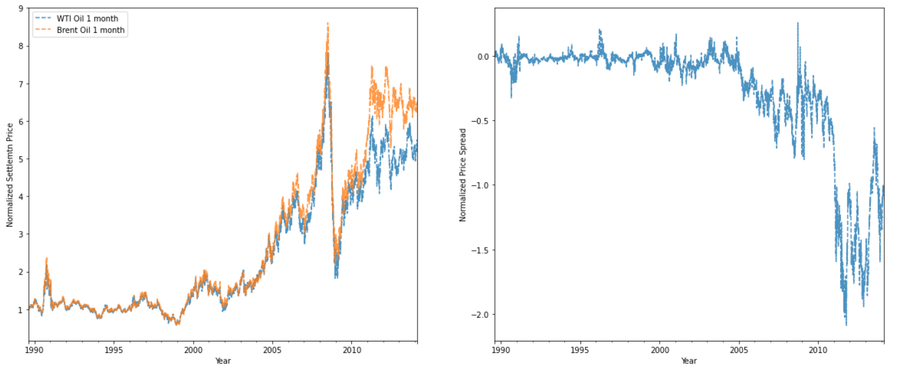

Figure 2. Two-month Oil Futures Price and Spread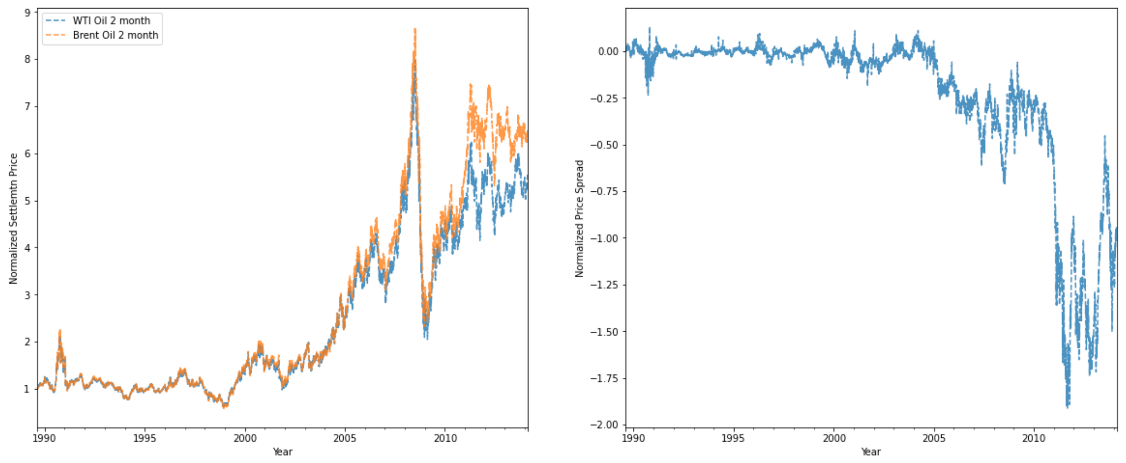

Figure 3. Three-month Oil Futures Price and Spread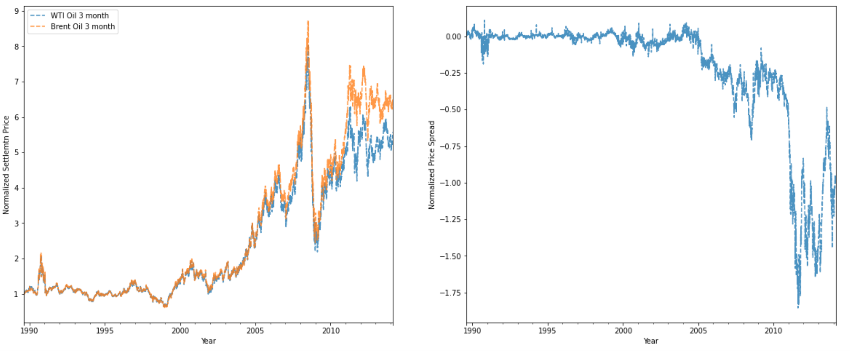

Moreover, before implementing the mean-reverting spread trading strategy, our team wanted to have a big picture of how the trading signals are generated with different lengths of moving average window and ensure spread trading strategy is viable. As figure 4 shows, the shorter the moving average window applied, the more trading signals can be caughts. Also, the mean-reversion strategy is viable since we cannot observe a distinct pattern of how entry and exit signals are generated and the appearance of trading signals seems to be random over time. In another word, we cannot attribute the appearance of trading signals to any type of market states.

Figure 4. Z-score of WTI and Brent Futures Price Spread

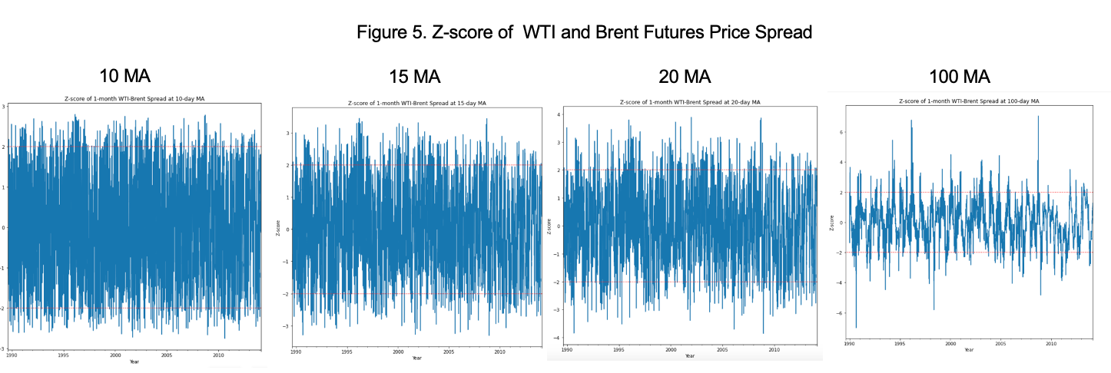

Additionally, to roughly test the assumption that the oil futures market in the long term is efficient, our team built a naive buy-and-hold trading strategy to get a high-level picture of the oil market. If buy-and-hold strategy can consistently achieve a high annualized sharpe ratio after discounting risk-free rate, that means the oil future markets might not be as efficient as it seems to be. As Table 2 shows, our team selected the period before the three greater financial crisis, after taking risk-free rate into account, naive buy-and-hold trading strategies got a negative risk-adjusted sharpe ratio in all different periods. As Figure 5 shows, you can see the naive buy-and-hold strategies performed poorly over time. To some extent, in our view, the oil futures market should be efficient in the long term. These results also intuitively make sense, since we would not expect commodities to appreciate in the long run like stocks would.

|  |  |  |  |  |
| --- | --- | --- | --- | --- |
| Table 2. Sharpe Ratio (Buy & Hold) | | | | |
| **Period** | **Before 1997** | **Before 2000** | **Before 2008** | **The Entire Dataset** |
| 1-month WIT-Brent Spread | -0.465 | -0.574 | -0.478 | -0.381 |
| 2-month WIT-Brent Spread | -0.608 | -0.753 | -0.660 | -0.548 |
| 3-month WIT-Brent Spread | -0.674 | -0.833 | -0.713 | -0.600 |

Figure 5. Buy-and-hold Strategies for trading spread between WTI and Brent Futures

# 3.0 Implementation

## 3.1 Mean-reverting trading strategies

The mean reversion strategy assumes that asset prices and returns eventually will revert to the long-run mean or average level; in other words, mean-reverting trading tries to capitalize on extreme changes in the pricing of a particular security, assuming that the asset price will revert to its previous state (e.g. if the asset price outperforms, it will underperform in the future and vice versa.). However, a single asset that is mean-reverting is hard to find. Therefore, instead of applying a mean-reverting trading strategy on any single energy future, we decided to focus on the spread between energy futures, as the spreads between some pairs of futures are more likely to be stationary and show a mean-reverting pattern. Such stationary spread can be constructed by buying and selling two cointegrated futures with an appropriate hedge ratio.

### 3.1.1 Cointegration

To confirm whether any pairs of future products with the same delivery month from Crude Oil market have strong cointegration, we run the augmented Engle-Granger two-step cointegration test, and the result is as follows:

|  |  |  |
| --- | --- | --- |
| Table 3. Cointegration test | | |
| **Pairs** | **T - statistic** | **P - value** |
| WTI Front - WTI 2nd Spread | - 6.702941 | 4.291000e-08 |
| WTI Front - WTI 3rd Spread | -5.540970 | 1.481618e-05 |
| WTI Front - WTI 4th Spread | - 5.169764 | 7.928694e-05 |
| WTI Front - WTI 5th Spread | -5.217211 | 6.436948e-05 |
| WTI Front - WTI 6th Spread | -5.241931 | 5.770460e-05 |
| WTI 2nd - WTI 3rd Spread | -5.177534 | 7.663584e-05 |
| WTI 2nd - WTI 4th Spread | -4.903858 | 2.463771e-04 |
| Brent Front - Brent 2nd Spread | -5.450838 | 2.247969e-05 |

The results showed that there were many pairs of futures with strong degrees of cointegration. In other words, there exists a linear combination of cointegrated futures that is stationary. We constructed hedge portfolios for these pairs and performed mean reverting trading strategy on the spread.

### 3.1.2 Hedge ratio

To determine the linear combination of cointegrated futures, we introduced time varying in- stead of static coefficients; in other words, we used a dynamic hedge ratio as the value of the hedged portfolio (spread) should be kept relatively stable. We decided to use this method because we noticed that the linear relationship between any pair of futures tended to be time-varying, particularly in the past decade. As mentioned above, sometimes the energy futures market might not be efficient in the short term and sensitive to new information; therefore, the introduction of a time-varying hedge ratio is reasonable. We used a dynamic linear model in state space form with a *Kalman Filter* to update the estimated hedge ratio whenever new information is received. Following (Figure 6) is a sample of the dynamic ratio and intercept of WTI Front vs. WTI 2nd month:

Figure 6. Dynamic hedge ratio and intercept change for WTI Front vs. WTI 2nd month

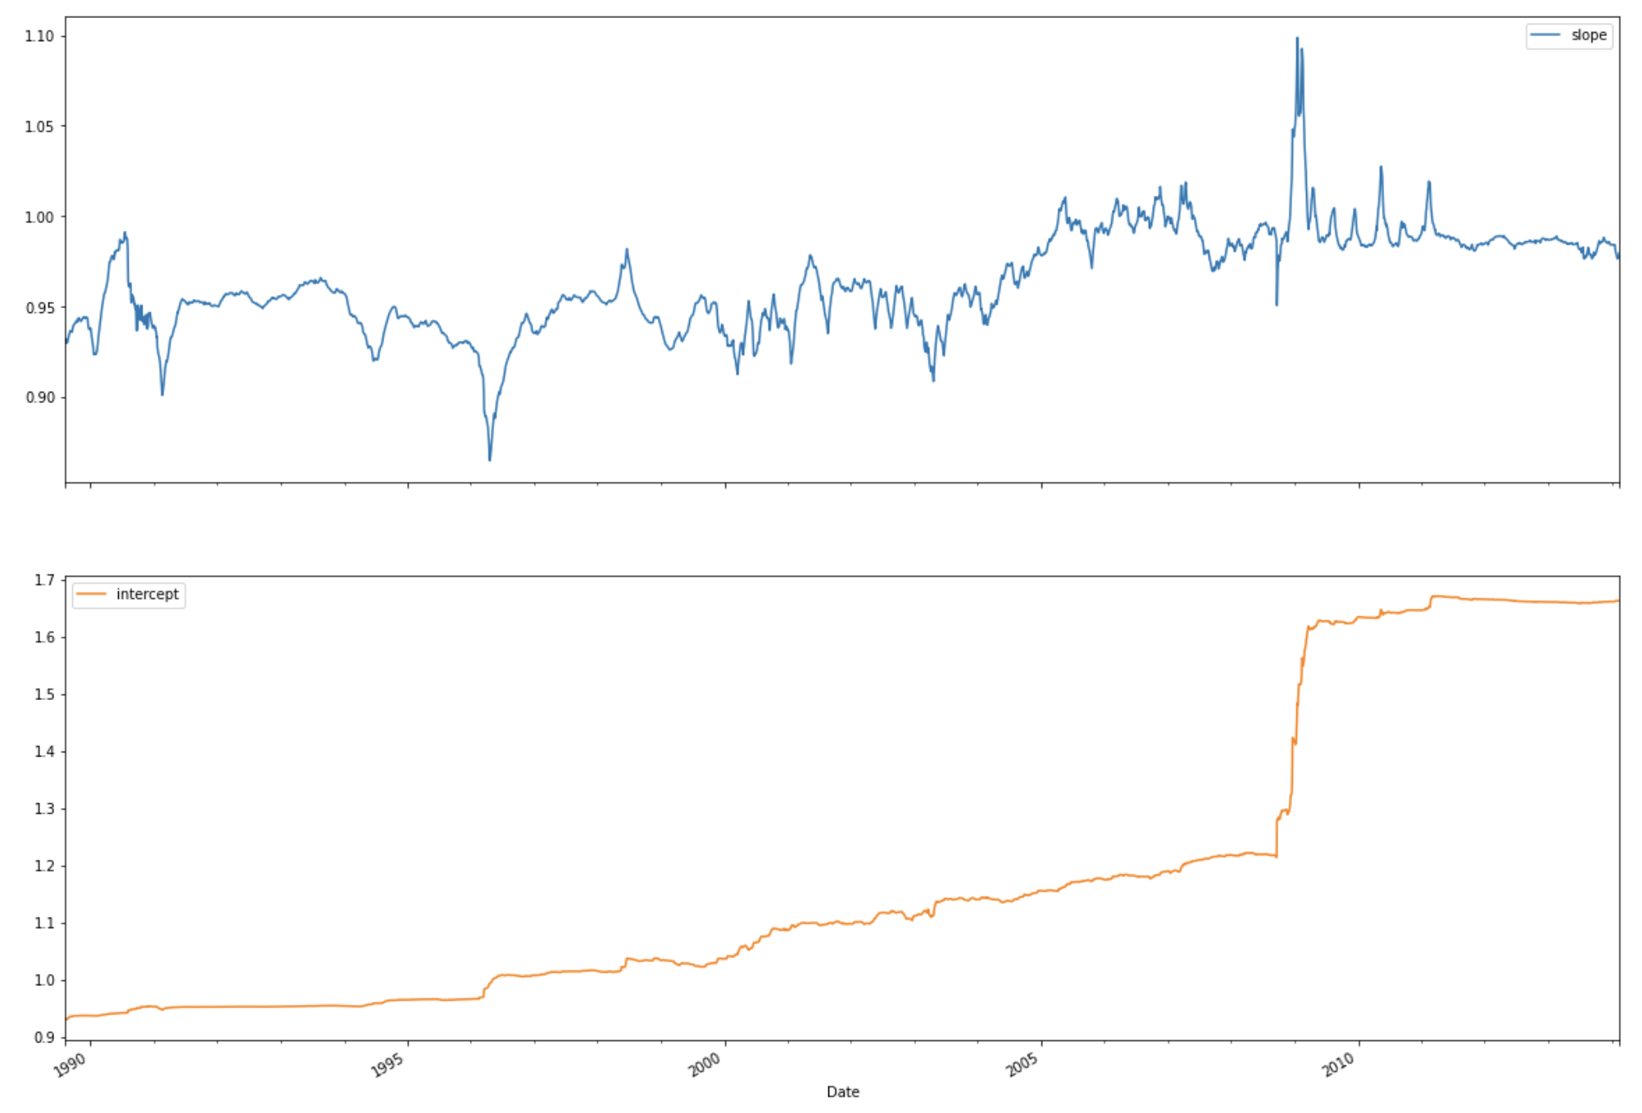

### 3.1.3 Mean-reverting strategy on hedge portfolios

After constructing several hedge portfolios, we implemented mean-reverting strategy and used the *Bollinger Band* to generate entry and exit trading signals. The signal indicator is calculated as follows:

$Z_{t} = \frac{P_{t }- {MA}_{t}}{σ_{t}}$,

where $P_{t}$ is the spread (the value of the hedge portfolio), ${MA}_{t}$ is the simple moving average of the spread for a given length, $σ_{t}$ is the rolling standard deviation of the spread with the same length as the moving average. We tried moving averages and rolling standard deviation of length 10, 15, 20, 50 and 100 (days).

Entry signals are generated whenever the indicator z-score reaches certain extreme values, which are determined by the number of standard deviations away from the moving average. We chose 2 standard deviations away, both positively and negatively, as extreme (statistically, z-score of **±** 1.96 means the diverge is significant with 95% confidence level, so we’re conservative here). Specifically, the entry signal for a long position in the hedge portfolio is triggered whenever the z-score indicator reaches values below −2, while the entry signal for a short position is generated as soon as the z-score is above 2. To clarify, a long/short position in the hedge portfolio means a long AND a short position of the underlying two futures forming the spread.

Exit signals are generated when the indicator z-score reaches certain specified values. Here we tested z-score to be -0.5, -0.2, 0 ,0.2 and 0.5. The indicator z = 0 means that the long or short position of the hedge portfolio is closed whenever the portfolio value reaches the moving average. The positive z-score (z = 0.2/0.5) is implemented because some authors stated that price movements will not stop at the moving average but tend to overshoot this mark. To account for the potential profit from this overshooting, we used positive z-score indicator, which means that we would close a long or short position when the price has crossed the moving average and moved a little bit further; in other words, exit a long position of hedge portfolio when z >=0.2/0.5, and exit a short position of hedge portfolio when z<=-0.2/-0.5. We also included negative z-scores to be more conservative about the reversion strategy; instead of waiting for the spread to revert to its moving average level, we exit the position early when the value reverts to a certain range of mean value; in other words, exit a long position of hedge portfolio when z >=- 0.2/-0.5, and exit a short position of hedge portfolio when z<=0.2/0.5. Note that all signals are lagged by 1 day to be more conservative. In another version of mean-reverting strategy that the results did not take this 1-day lag, all sharpe ratios were approximately doubled.

For calculation of returns, we used the average price level of the two future contracts as our investment or employed capital. In addition, we exclude value changes during contract roll-over days from our portfolio return calculations, so that the gain/loss and the value of sharpe ratio fully come from the implementation of mean-reverting strategies on the spread of two cointegrated future contracts. Contract roll occurs during the first day of each month, so anytime we held positions in the market during the first of the month, the returns achieved that day were excluded from our portfolio return calculations.

## 3.2 Momentum

In addition to the mean-reversion strategies, we also tested a cross sectional momentum based strategy. To implement our momentum strategy, we calculated the return momentum of all commodities over the previous 15, 30, 45 and 60 days. For each time horizon we then separated the assets into quintiles, with quintile 1 having the lowest return momentum, and quintile 5 having the highest. Essentially, quintile 5 indicates assets we want to long, and quintile 1 indicates assets we want to short. Overall, this resulted in 4 similar momentum based trading strategies, with each differing only in the number of days used to calculate momentum for the entry and exit signals. This strategy aims to capitalize on existing momentum in the returns of the futures contracts.

## 3.3 Volatility

To implement the volatility strategy, we calculated the volatility of the returns for all commodities over the previous week, month and the relative volatility. Similar to the momentum strategy, we used the quintile approach to devise our trading strategy. We tried two approaches within volatility:

1. Buy when volatility is low, sell when volatility is high.

We buy futures contracts which are in quintile 1 and sell contracts which are in quintile 5.

1. Buy when volatility is high, sell when volatility is low.

We buy futures contracts which are in quintile 5 and sell contracts which are in quintile 1.

# 4.0 Testing

## 4.1 Mean-reverting Strategies

To deeply understand whether our mean-reverting trading strategy performance is robust, our team tried different combinations of MA windows, exit signals, and hedge ratios (no hedge ratio or dynamic hedge) and compute sharpe ratio for each combination.

### 4.1.1 Variation 1: No hedge ratio (Inter-commodity spread)

In this case, our team simply sets the hedge ratio for each spread trade to 1:1, which means when our team buys one contract, we will sell another contract simultaneously. As Figure 7 shows that, in general, the shorter MA window, the higher sharpe ratio our team can realize across different inter-commodity spread trades. At the same time, as the exit signal gets smaller, the sharpe ratio for each trade will also get higher. Generally, the testing on moving average windows does confirm our assumption that the oil market is subject to short-term inefficiencies and our team’s mean-reverting trading strategy with a shorter moving average window can capture more such short-term information shocks and thus achieve a higher sharpe ratio.

Figure 7. Sharpe Ratio of different Combinations of MA windows and Exit Signal (hedge ratio= 1:1) 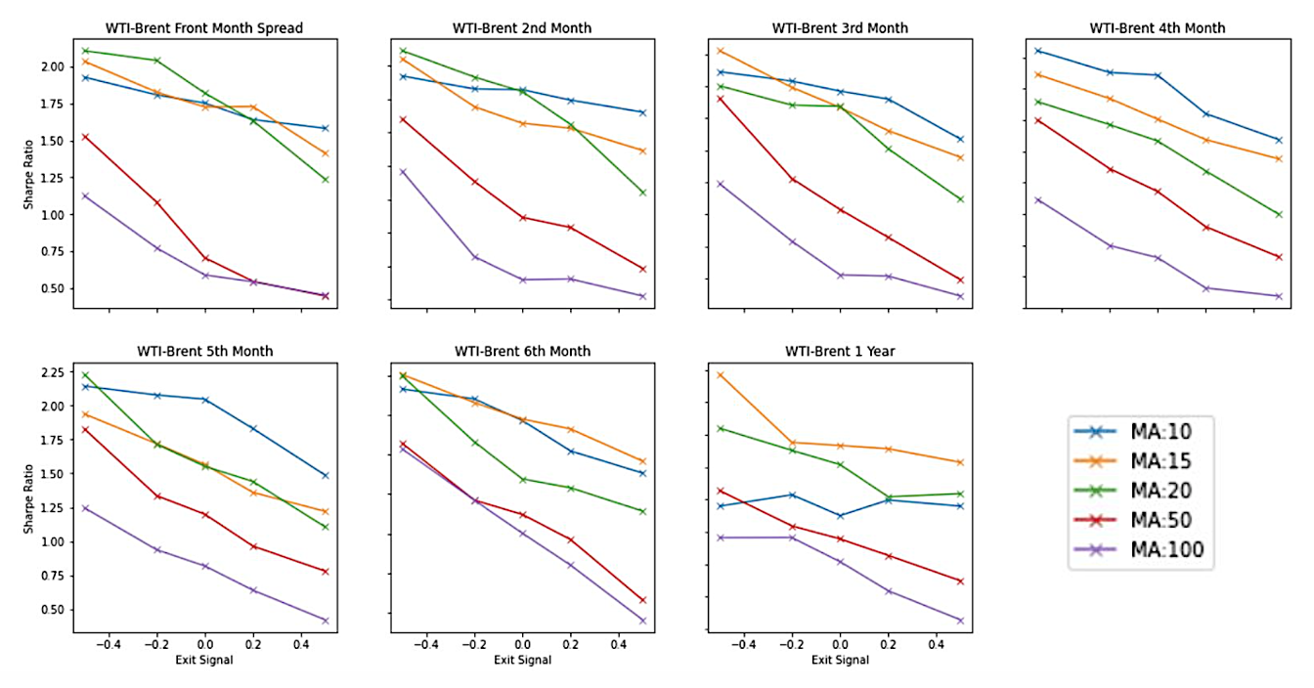

### 4.1.2 Variation 2: Dynamic Hedge for Inter-commodity Spread

Since our team applied dynamic hedging techniques in our mean-reverting strategy, the strategy can more accurately capture the relationship of spread between two futures contracts, and thus it is expected that performance of all combinations is significantly improved. Also, as Figure 8 exhibits, in general the faster the exit signal, the higher the sharpe ratio can be achieved. However, for near term futures contracts, MA window does not matter much, whereas longer MA seems to be better for longer term futures contracts.

Figure 8. Inter-commodity Sharpe Ratio of different Combinations of MA windows and Exit Signal (dynamic hedge)

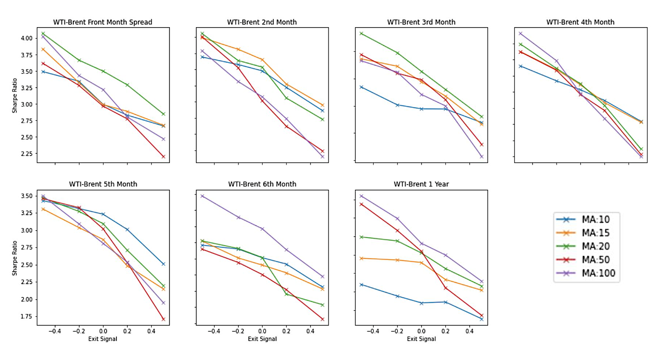

### 4.1.2 Variation 2: Dynamic Hedge for Calendar Spread

As we can see from Figure 9, a faster exit signal also works the best for calendar spread with dynamic hedging ratio. Also, shorter MA such 15, 20 and 50 days seems to work the best for WTI calendar spread trades, whereas Brent calendar spread trades is exactly the opposite, in which a longer MA window like 50 and 100 days generally performs the best in our case. We can also see that for calendar spread, 10-day moving average windows in general does not work as well as cases mentioned above.

Figure 9. Calendar Spread Sharpe Ratio (dynamic hedge)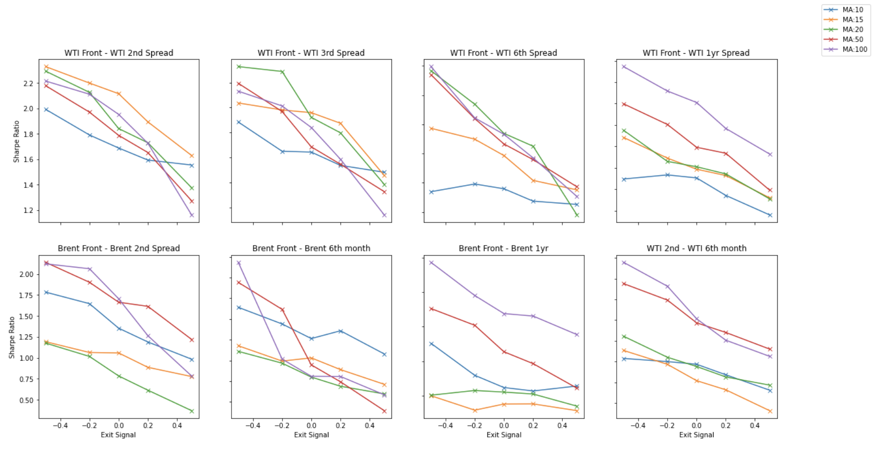

### 4.1.3 Portfolio Performance

As you can see in Figure 10, the trading strategy kept performing well, even during times of financial/political turmoil, such as when the oil price collapsed due to the 2008 financial crisis. To create portfolio metrics, we used the base case trading strategy, which involved a moving average length of 20 and exit signal=0 on the WTI-Brent front month contract. The most notable observation with the portfolio was the extremely low volatility it was able to achieve and the minimal amounts of drawdowns it experienced. To be more specific, based on Table 4, there were around 61.2% of total trading days that our trading strategy was able to gain profits. In total, the trading strategy made 287 trades, with each position being opened and closed for a period of 5.2 days on average. The portfolio was in the market about 22% of the time and during this time, the maximum drawdown ratio was just -1.7%. The rate of return was around 3.8 times over the 25-year trading period of the dataset and around 6% per annum. While the results seem somewhat mediocre based on the 6% annualized return, when we take into account the leverage of futures contracts (i.e. roughly 10:1 leverage on WTI; we can take $43K exposure by paying $4500 of margin upfront), our rate of return is potentially magnified ten-fold. To summarize, when taking into account the volatility and return of our trading strategy, it can be viewed as an extremely low-risk but high return strategy.

Figure 10. Portfolio Performance with 20-day MA and exit signal = 0

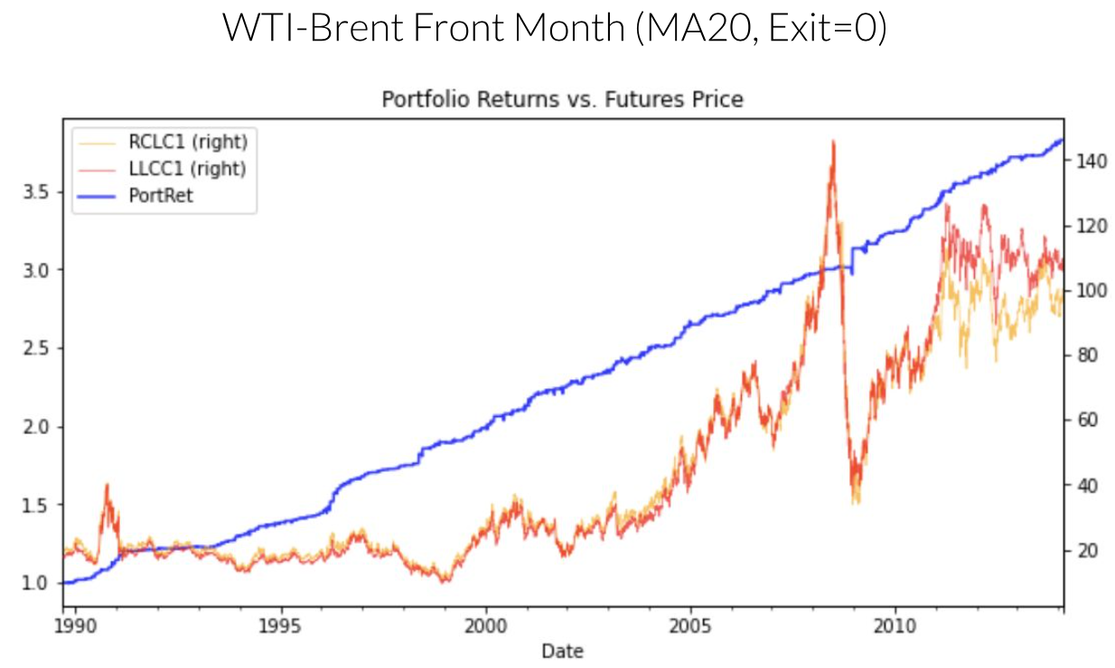

Table 4. Performance Metrics of Mean-Reverting trading Strategy

|  |  |
| --- | --- |
| Max drawdown | -1.7% |
| Number of trades | 287 |
| Up days | 61.2% |
| Time in market | 22.5% |
| Average holding periods | 5.2 days |
| Rate of return | 3.8x over 25 years (around 6% annualized) |

## 4.2 Momentum

Our initial skepticism concerning a cross sectional momentum based strategy for Energy futures proved to be well founded. This set of 4 strategies had some of the worst sharpe ratios of any we implemented. The best result of these strategies was a Sharpe ratio of 0.08, which we achieved by assessing the momentum of each contract over the previous 45 days.

We suspect there are 3 reasons for the poor performance of the momentum based strategies. Firstly, unlike stocks, commodities do not tend to appreciate over time, so we can expect any gains to be matched by corrections of similar magnitude. Secondly, due to limitations in availability of data for certain commodities, our trading period for all commodities is from 2005 to 2014: a period in which momentum-based trading strategies performed poorly historically. Lastly, the basket of contracts in our sample contains futures for crude oil, natural gas, heating oil, and gasoline. Among each of these commodities, we expect assets to behave in a similar fashion, so any differences in momentum within our samples could be due to random fluctuations, meaning momentum relative to other contracts of a similar type is not suitable as a trading signal.

Overall, we do not recommend a cross sectional momentum based trading strategy for energy futures, as empirically we see excess returns that are not significantly different from zero. In addition, as we can see from the plots of excess returns below, the returns of portfolios using this strategy for energy futures resemble random noise. Leading us to believe that any positive returns gained through these strategies are a result of chance.

Table 5. Performance of Momentum Based Strategies

|  |  |  |
| --- | --- | --- |
| **Time Horizon** | **Sharpe Ratio** | **T-Stat (excess returns)** |
| 15 days | -0.082 | -1.091 |
| 30 days | 0.067 | 0.894 |
| 45 days | 0.079 | 1.053 |
| 60 days | 0.027 | 0.365 |

Figure 11. Excess returns of 15 day Momentum Based Strategy

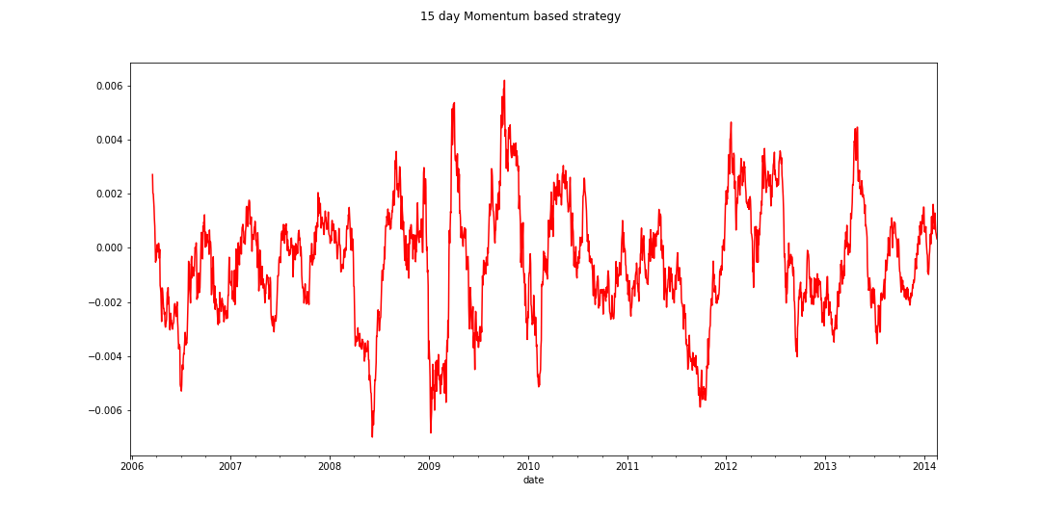

Figure 12. Excess returns of 30 day Momentum Based Strategy

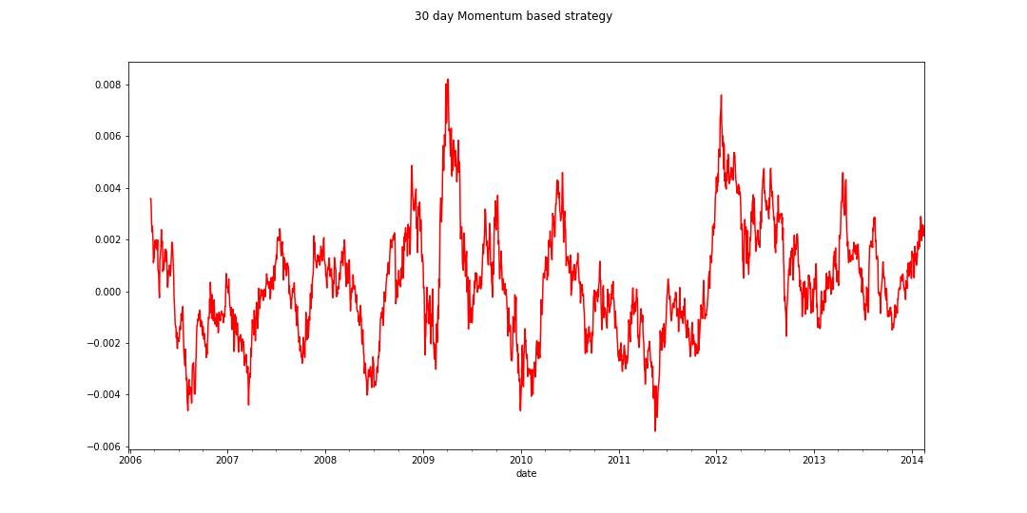

Figure 13. Excess returns of 45 day Momentum Based Strategy

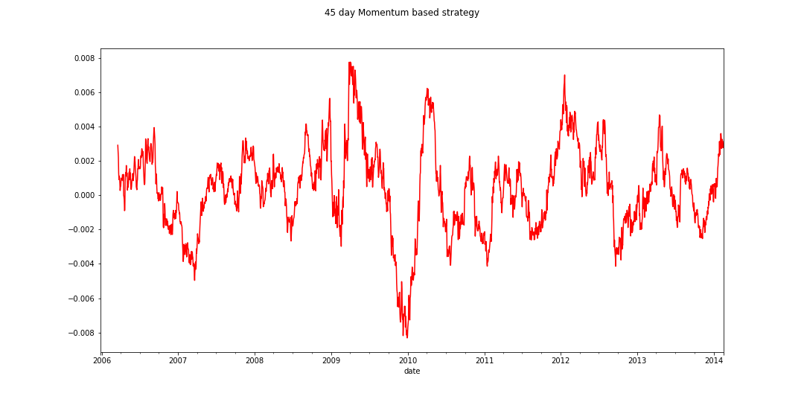

Figure 14. Excess returns of 60 day Momentum Based Strategy

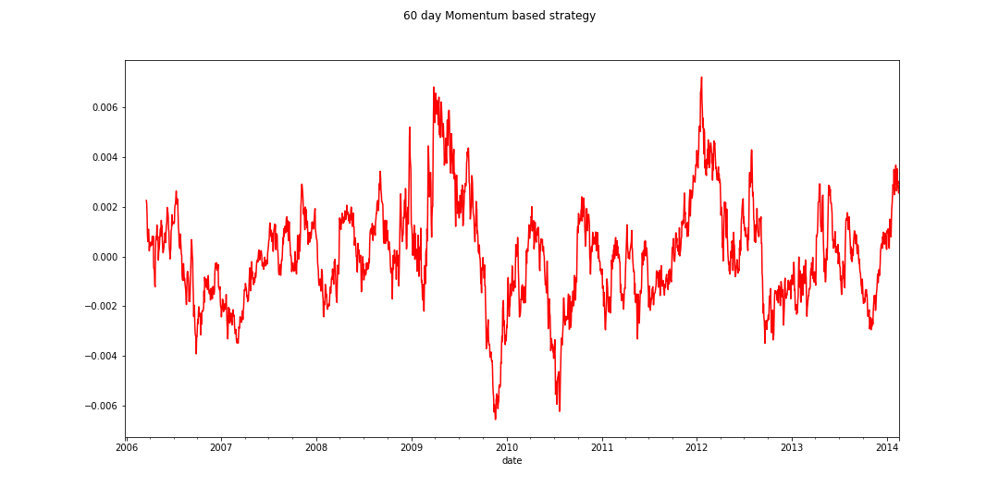

## 4.3 Volatility

Using the two sub-strategies for volatility we had listed in the previous section, our results indicated that oil futures tend to give better returns when volatility is high. Using our first approach i.e buying when volatility is low and selling when volatility is high, our Sharpe ratios for the three time horizons under study were all negative.

We achieved our best Sharpe ratios of 0.105 and 0.101 for relative volatility and monthly volatility respectively, when we purchased highly volatile oil futures. Given this performance, we do not recommend using volatility-based trading strategies on oil futures.

Table 6. Performance of Volatility Based Strategies

|  |  |  |  |  |
| --- | --- | --- | --- | --- |
| **Time Horizon** | **Sharpe Ratio** | **T Stat** | **Sharpe Ratio** | **T Stat** |
| Buy when volatility is high, sell when it’s low | | | Buy when volatility is low, sell when it’s low | |
| 1 week | 0.07 | 1.04 | -0.07 | -1.04 |
| 1 month | 0.101 | 1.37 | -0.101 | -1.37 |
| Relative | 0.105 | 0.14 | -0.105 | -0.14 |

Figure 15. Excess returns of 1 week based buying at high volatility strategy

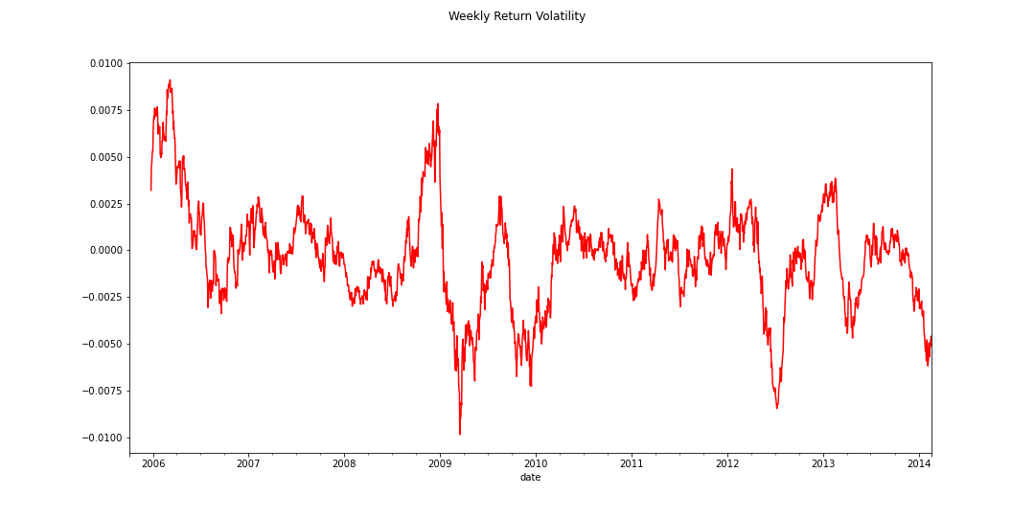

Figure 16.. Excess returns of 1 month based buying at high volatility strategy

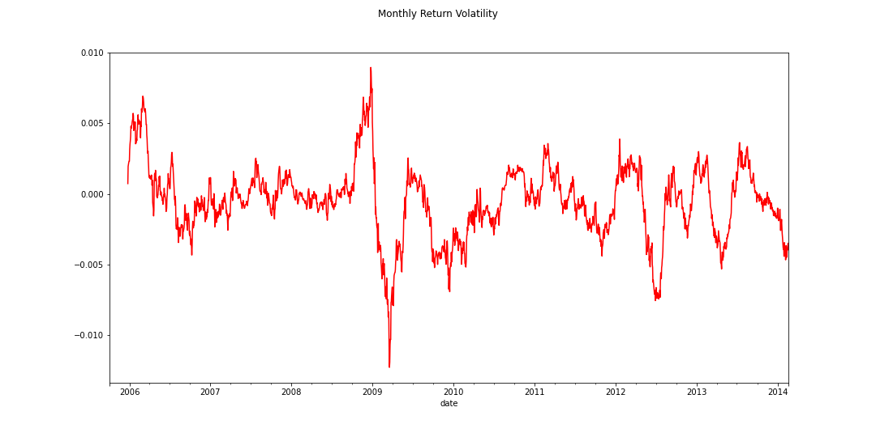

Figure 17. Excess returns of week relative to the month based; buying at high volatility strategy

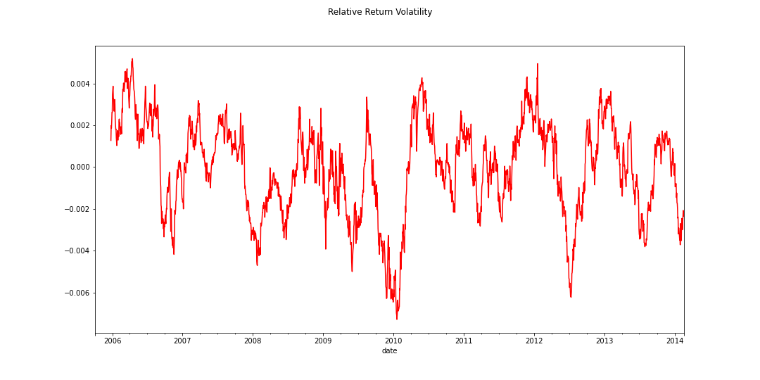

# 5.0 Conclusion and Future Works

Based on the trading performance of three strategies, mean-reverting strategies with time-varying hedge ratio performed the best over time and successfully monetized short-term information shocks over the trading period, whereas momentum and volatility trading strategies do not work as well as expected. To some extent, our testing proves that the energy futures market in general tends to reverse rather than to follow a trend. This factor also contributes to a high sharpe ratio achieved by using *Bollinger Band* to generate entry and exit signals.

However, there are limitations for the mean-reverting strategies. Firstly, when selecting a good pair of futures contracts, our team did not take volume and transaction costs into account. Also, when trading futures contracts, our team should also factor in contract roll every month instead of dropping it when our team implemented mean-reverting strategy, making our strategy closer to a more realistic and practical trading context.

For future works, our team can apply the mean-reverting trading strategy on high-frequency data during the most recent period (e.g 2015 - 2020) to see if trading performance is sufficiently robust.

# References

B.M. Tabak, D.O. Cajueiro

Are the crude oil markets becoming weakly efficient over time? a test for time-varying long-range dependence in prices and volatility

Energy Econ., 29 (2007), pp. 28-36

J. Alvarez-Ramirez, J. Alvarez, E. Rodriguez  
 Short-term predictability of crude oil markets: a detrended fluctuation analysis approach

Energy Econ., 30 (2008), pp. 2645-2656

N. Koch

Tail events: a new approach to understanding extreme energy commodity prices

Energy Econ., 43 (2014), pp. 195-205

P.B. Girma, A.S. Paulson

Risk arbitrage opportunities in petroleum futures spreads

J. Futur. Mark., 18 (1999), pp. 931-955

T. Lubnau, N.Todorova

Trading on mean-reversion in the energy futures market, [Energy Economics](https://www.sciencedirect.com/science/journal/01409883)

vol. 51 (2015), pp. 312-319

W.E. Shambora, R. Rossiter

Are there exploitable inefficiencies in the futures market for oil?

Energy Econ., 29 (2007), pp. 18-27